EXPLORE THE WORLD WITH SHEAFE’S FLAT BLUEBIRD
Due: Friday, March 16, 2012
STUDENT NAME: _________________________________________________ ROOM _______________
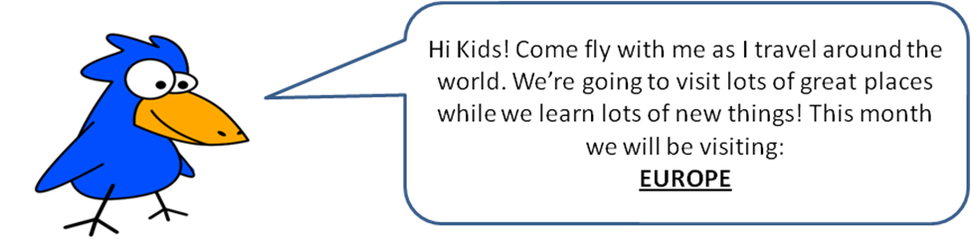
Last week, I landed in Europe. So far, I have traveled to Iceland, Ireland, Great Britain and France. This week I’m traveling to more countries in Europe. Come along with me!
Do you remember where France is? See the two islands (a body of land that is completely surrounded by water) under the word Europe. France is directly south of those two islands (Ireland and England). From France, travel northeast. You are now in Germany. While in Germany, I’m going to stop at Zoo Berlin. It has the largest number of species in the world. From Germany, I’m flying south to Italy. It is the long country. The bottom of Italy looks like a boot! I’m going to Rome, the capital of Italy. Rome is also known as the Eternal City and is about 3,000 years old! From Italy, I’ll fly over the Mediterranean Sea to Spain. Remember Christopher Columbus? He was born in Italy, but Spain is the country that gave him the money for his trip. Right next to Spain (to the west) is the country of Portugal. The longest bridge in Europe is located in Portugal. It is over 10 miles long. I can’t wait to fly under that bridge! I bet you can’t wait to find out what countries I’ll visit next week! ☺
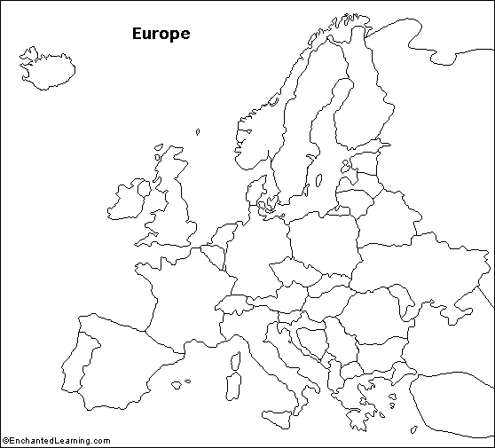

Color and label the flags for Germany and Spain.

Using the information above and the compass rose, color and label the following countries:
Germany – orange
Italy – purple
Spain – yellow
Portugal – red

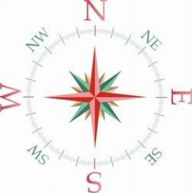

The flag of Spain has three horizontal stripes. The top and bottom stripes are red. The middle yellow stripe is twice the size of the red stripes. The coat of arms is in the yellow stripe.
The flag of Germany is tri-color. Black is the top color, followed by red and gold is the bottom color.
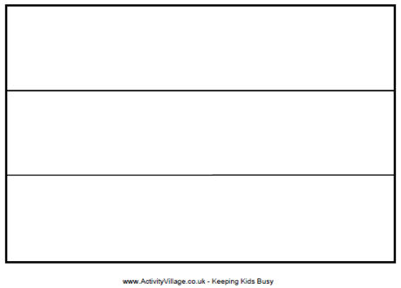
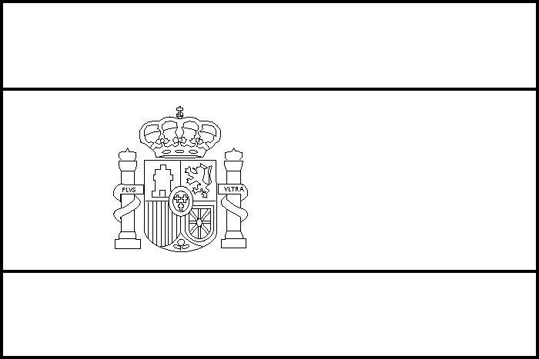

With adult permission, do some research and see if you can find out the answers to the following questions about Germany. Good luck!
1. What is the capital city of Germany? _________________________

2. Name the 9 countries that border Germany.
_________________________, _________________________, _________________________
_________________________, _________________________, _________________________
_________________________, _________________________, _________________________

3. Unscramble the letters to make another name for Germany.
danchlteuDt _________________________

4. After World War II Germany was split into two separate states, the Western Federal Republic of Germany and the Eastern Republic of Germany. A large wall was built in 1961 separating the country. Family members living on different sides of the wall were unable to visit each other.
On what date did the wall come down making Germany a unified single state again?
________________________________________________

5. What was the name of the United States President that gave a speech in front of the Brandenburg Gate in West Germany saying, “Mr. Gorbachev, tear down this wall!”
________________________________________________

6. What is the name of one of the world’s most renowned German scientists who was a physicist, won the Nobel Peace prize, and was born in Ulm, Germany?
______________________________

7. What type of clock was invented in the 17th century in Germany that features a small bird appearing through a wooden trap door on the hour, chirping?
______________________________

